

**SPIRIT Software**

version 2.1 - 08.11.2014

**What is SPIRIT?**

**SPIRIT is a Java-based software to handle complex life science research data. It was originally deve­­loped for internal use by Actelion Pharmaceuticals Ltd. (Switzerland).**

**SPIRIT is used by more than hundred researchers in Actelion’s Drug Discovery Departments. It is also used by the Actelion Research Biobank to manage its preclinical and clinical samples and data.**

**SPIRIT’s data concept is generic and sample-centric. It can be configured to handle any type of samples and their relationships, including animals or humans. Results can be linked to samples and have an unlimited number of input and output parameters. Physical storage locations are managed by a fully configurable inventory system. Finally, a graphical study editor allows to plan, display, and record the progress of experiments involving groups of samples and results over time.**

**Software Structure**

SPIRIT presents **four perspectives** to the user. Each perspective has its own tab in the main program window, but they are all linked. In these tabs, the user can do the following:

**Samples** Create samples, find and display them as well as all related samples,  
 edit sample information, print labels  
 (Administration: Define sample types and their parameters)

**Locations** Register the location of samples and containers, find and move them,  
 display inventory lists, print container labels (Admin.: Create locations)

**Results** Store results, find and display them in pivoted tables, export results  
 in spreadsheet format, visualize them in the DataWarrior software  
 (Administration: Define tests)

**Studies** Graphically design and monitor the evolution of a **study** (experiment).

**Studies** consist of the following elements:

* multiple **samples** (including animals or humans) that are
* arranged in **groups** and subgroups (such as treated *vs.* control)
* in different **phases** (or time points) at which they are planned to
* undergo **treatments**,
* **samplings** (generating new samples), and
* **measurements** (generating results)

**Database**

SPIRIT can be used with any relational database, such as Oracle or mySQL.

**Configuration**

Each implementation of SPIRIT requires the definition of **sample** **types** (such as animals, blood, organs, DNA, cells) with their parameters; **container types** and **storage locations**, and **tests** to store results.

SPIRIT also requires the registration of **users** with different rights. Users may be part of a **group** with specific rights. It is delivered with its own user database or it can be connected to an existing system.

**Extensions**

SPIRIT links directly with Actelion’s **DataWarrior** software to filter and display complex, multidimensional data. DataWarrior is available for free from [www.openmolecules.org](http://www.openmolecules.org).

The main SPIRIT software is accompanied by a suite of applications built to support specific users in dedicated tasks:

**AnimalCare** Monitoring of animal studies  
 (randomization, weighing, measuring, labeling)

**StockCare** Sample Inventory for cells, antibodies, etc.

**SlideCare** Generation of paraffin blocks and microscopy slides

**BioViewer** Simple sample information viewer with basic functionality  
 (scanning, aliquoting)

At Actelion, SPIRIT also integrates seamlessly with the company’s “Niobe” Electronic Lab Notebook (ELN) software, the “ORBIT” raw data file management system, and the “ORBIT Image Analysis” software.

**Collaboration**

SPIRIT is designed to provide many users a unified environment to manage their data, to collaborate, and to share their results. This is achieved by maintaining a single, system-wide configuration. Although users and groups have restricted rights, SPIRIT was not designed to completely isolate users from each other.

The latter could, in principle, be achieved through independent SPIRIT implementations. This will inevitably lead to diverging configurations, at the expense of data interchangeability.

**Audit trail, backup, data recovery**

Every modification in the SPIRIT database is recorded (time stamp, user, change). For each sample, a history can be displayed. Roll-back to a previous state is possible.

The database that SPIRIT connects with must be backed up, but no further backups are required.

Although SPIRIT stores its data in a relational database, it is possible to export its complete content in a (potentially huge) flat spreadsheet file at once.

**Hardware integration**

SPIRIT specifically supports this peripheral hardware:

* Brother P-Touch label printers
* barcode readers
* Mettler-Toledo balances

**Implementations**

* Actelion Pharmaceuticals Ltd., Allschwil, Switzerland  
  Drug Discovery Departments, including Actelion Research Biobank
* University Hospital Basel, Switzerland  
  Departement Biomedicine

**Contact Information**

* Software: [Joël Freyss](mailto:joel.freyss@actelion.com?subject=SPIRIT)
* Applications: [Geoffroy Bourquin](mailto:geoffroy.bourquin@actelion.com?subject=SPIRIT)
* Concept: [Oliver Peter](mailto:oliver.peter@actelion.com?subject=SPIRIT)

**Appendix 1: SPIRIT study concept**



**Appendix 2: SPIRIT Screenshots**

**Biosamples list:**

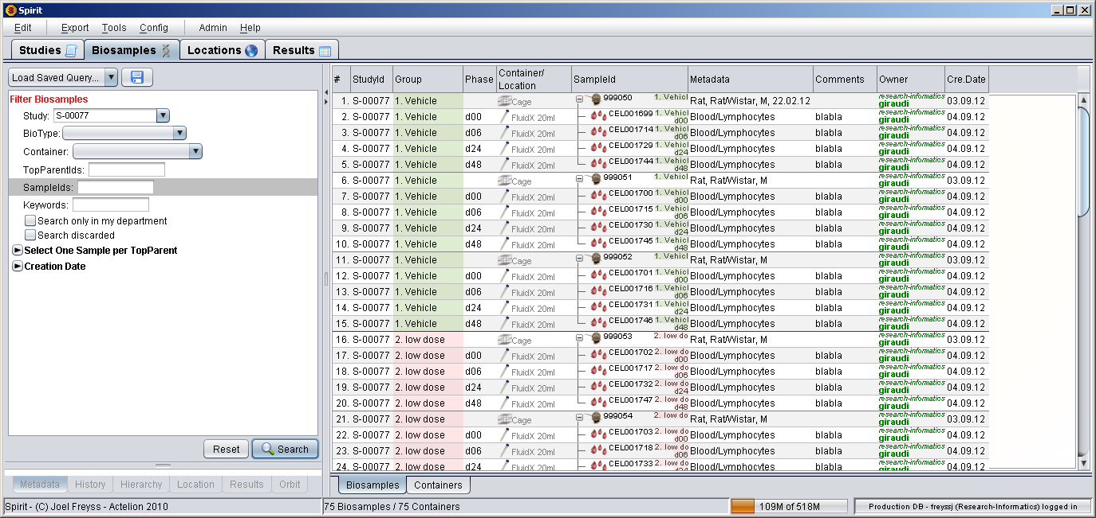

**Planning a sampling:**

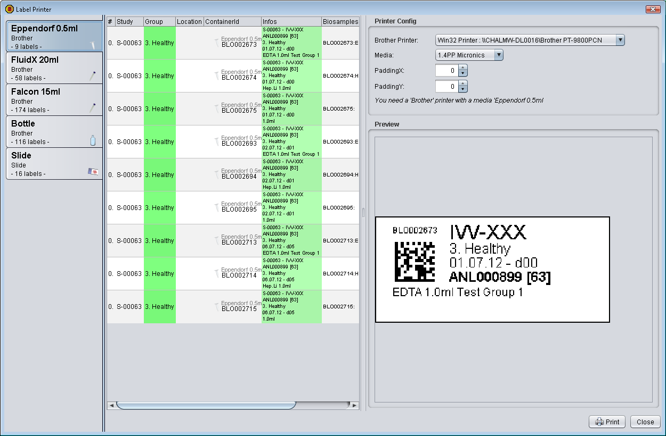

**Results list:**

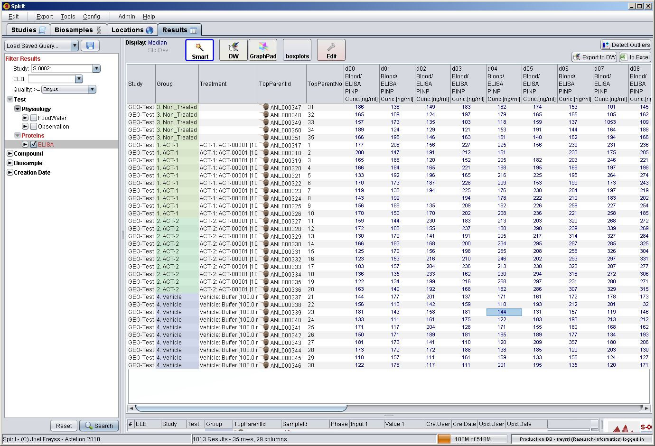

One-click export to DataWarrior:

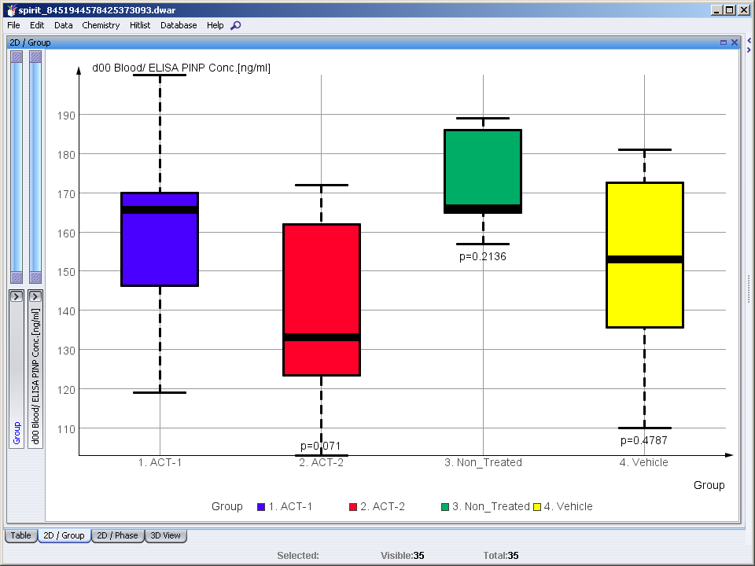 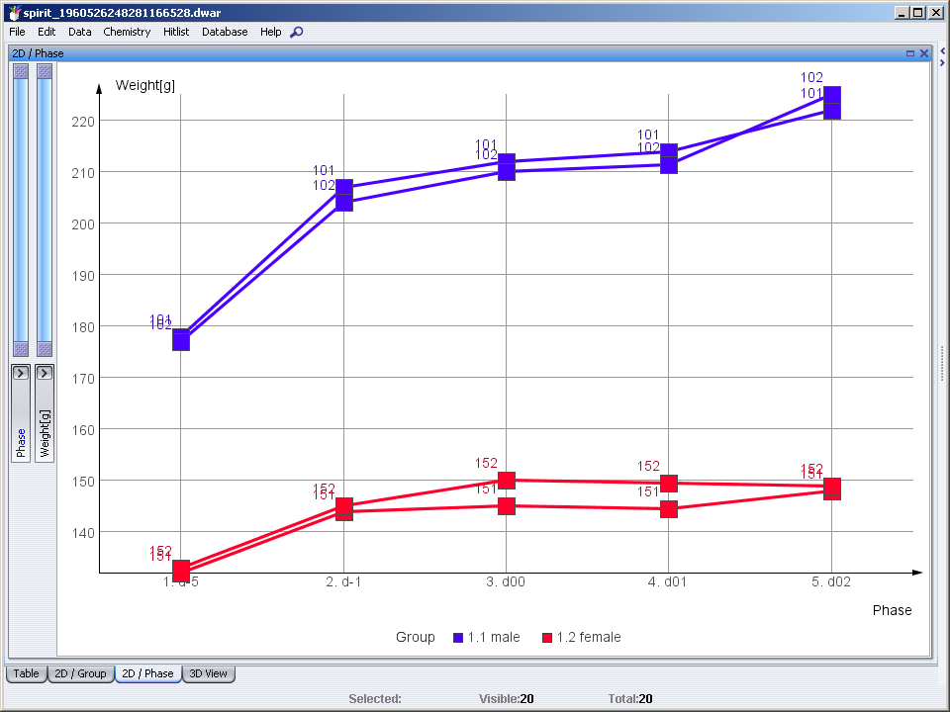

**Pivoting result tables:**

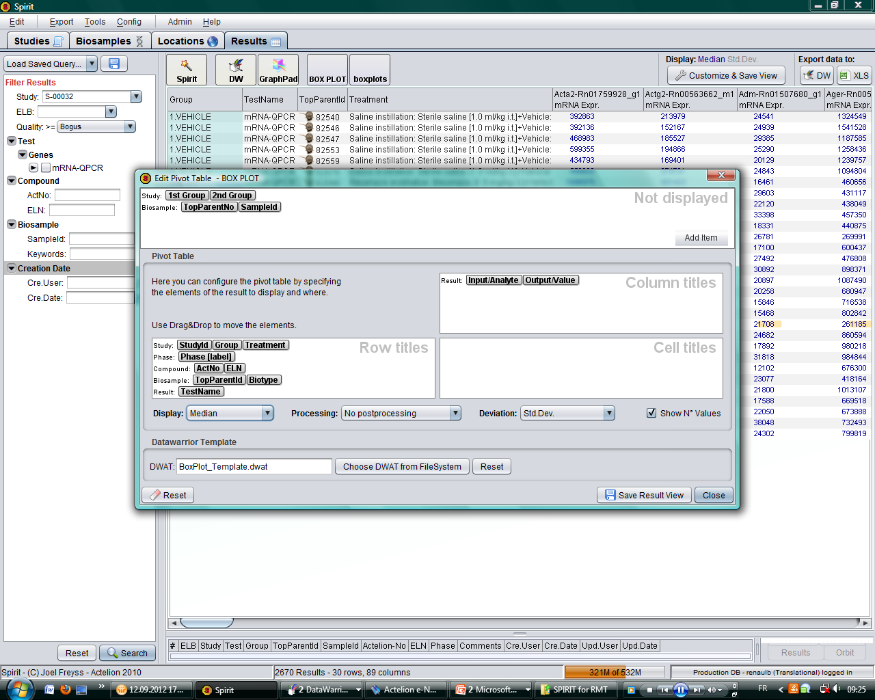

**Inventory management:**

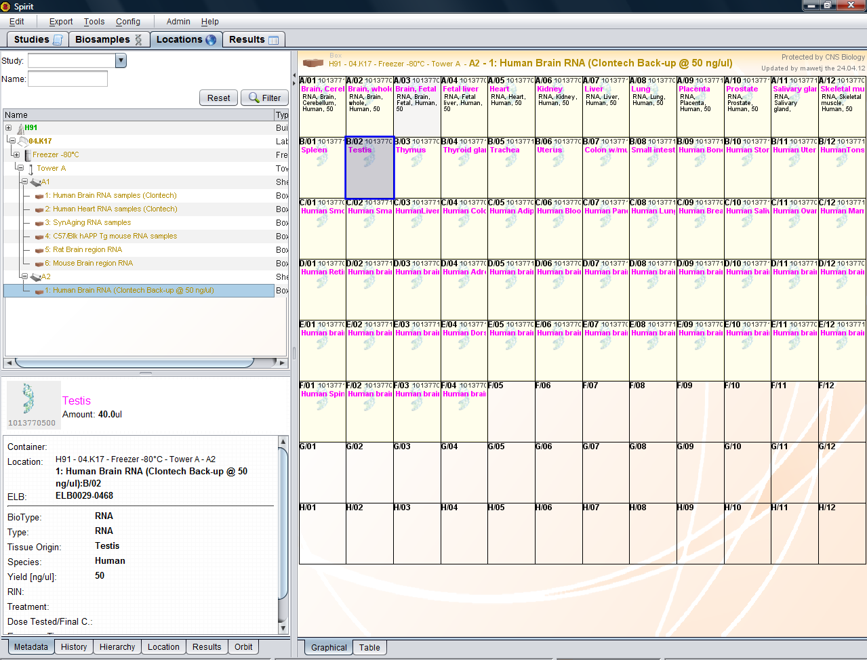

**Study screenshot:**

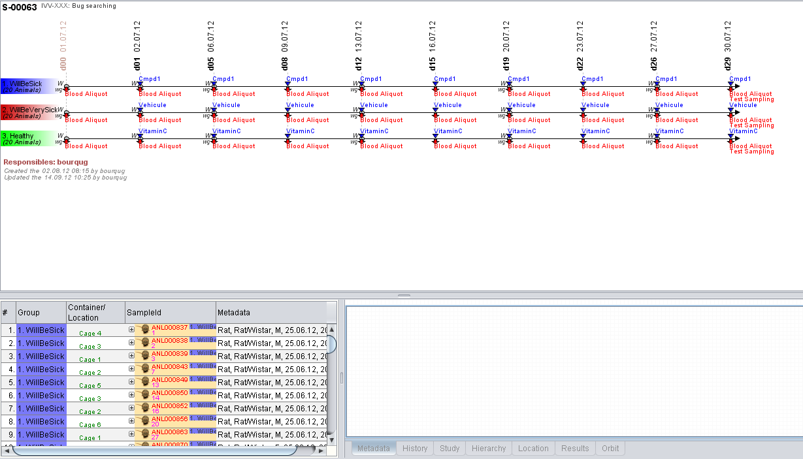

**SlideCare**

**SlideCare** is used by the histopatholy technician to

1. Define the sample arrangement on microscopy slides
2. Print the slide labels
3. Manage the slide inventory

